**RequestDispatcher -**

It is interface which is used to dispatching the request to another resource such as HTML, JSP, servlet etc.

There are two methods in RequestDispatcher as below

1. **public void forward(ServletRequest request,ServletResponse response)throws ServletException,java.io.IOException-**

It forwards a request from a servlet to another resource (servlet, JSP file, or HTML file) on the server.

1. **public void include(ServletRequest request,ServletResponse response)throws ServletException,java.io.IOException-**

It includes the content of a resource (servlet, JSP page, or HTML file) in the response.

forward method-

As you see in the below figure, response of second servlet is sent to the client. Response of the first servlet is not displayed to the user.

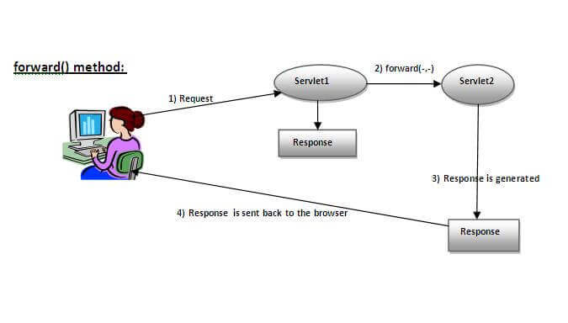

Syntax- public RequestDispatcher getRequestDispatcher(String resource);

Example-RequestDispatcher rd=request.getRequestDispatcher("success.jsp");

   rd.forward(request, response);

Note- in this example, The return type of getRequestDispatcher() method is RequestDispatcher that’s why we are able to write RequestDispatcher rd;

rd is the reference of RequestDispatcher interface.

include method-

As you can see in the below figure, response of second servlet is included in the response of the first servlet that is being sent to the client.

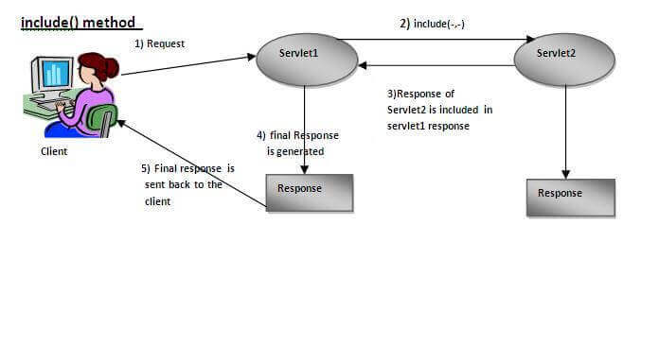

Syntax- public RequestDispatcher getRequestDispatcher(String resource);

Example-RequestDispatcher rd=request.getRequestDispatcher("success.jsp");

   rd.include(request, response);